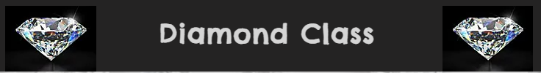
Welcome back! I hope you have all had an enjoyable summer. It has been wonderful to welcome the children back into class and see how excited they were to come in and see each other. There have been a few changes in Diamond Class since the summer term and I hope this newsletter outlines the important information. If you do have any questions or concerns, please speak to me at the end of the day or contact the office and I will call you back after school. Kind Regards, Miss Self.
Curriculum
English – during the autumn term children will be writing letter and poetry linked to climate change. They will then create some non-chronological reports about a new planet that has been discovered. After half term, they will use the text ‘Floodland’ to write new story endings and flashback stories. We will read the classic poem ‘The Highwayman’ and create our own poems in that style. During our Victorians topic, children will write diary entries from the perspective of a Victorian child.
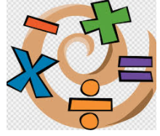
Maths – Over the next few weeks, the children will be consolidating their understanding of place value. They will then move on to the four operations, developing their ability to complete mental and written calculations.
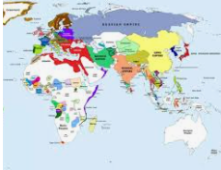
Science – During the first half term our science learning will be based on ‘Animals including humans’, focussing on the circulatory system, digestive system and functions of the main organs. They will discuss the importance of healthy lifestyles. After half term, our Science topic will be ‘Light’ learning about reflection, refraction and shadows. Children will have opportunities to plan and carry out investigations during both of these units.
Geography/History – we will start with a ‘Marvellous maps’ unit. Children will use compass points, grid references and a variety of maps to plan and follow routes/journeys. After half term, they will research what life was like to be a child in the Victorian era.
RE – our learning for the Autumn term will be based on Islam, learning about Tawhid. After half term, the children will find out about the Gospel and how Christians find wisdom when they need it.
Art/DT - will focus on the drawings of Hundertwasser and after half term they will design, make and evaluate a product made from felt.
PSHE – Our PSHE key questions will be ‘What makes up a person’s identity?’ and ‘What decisions can people make with money?’
Computing – During the first half term, Mrs Beckett will be teaching the children about online safety. They will improve their knowledge of the risks to their online lives. After half term, children will create their own version of the APP Crossy Roads using visual coding.
MFL – In French, the children will learn how to explain which leisure activities they enjoy.
PE - PE this term will be basketball and yoga. Children should come into school PE ready on Tuesdays and Fridays. PE kit should be in line with the School policy (see website)
Homework/Reading
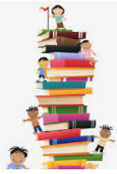
Children will have spellings to learn and practice each week – these will be set on a Monday and tested in class, the following Monday. All children have now chosen a reading book, which needs to be brought into school each day, along with their reading diary.
Please could children read at home 4 times per week and have their diary signed by an adult. Smilies will be awarded each week for this.
A range of Maths, English and topic home learning will be sent home on a regular basis. This will usually be set on Google Classroom, however, may occasionally be sent home on paper. Children will need to ensure that they can access their Google Classroom account from home.
Please can children continue to log in to Times Tables Rock Stars and complete 20 minutes per week. Again, smilies will be given for this each week as well as certificates for improvement.
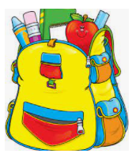
Rucksacks/Pencil cases
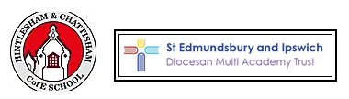
Children in Year 5 and 6 are permitted to use a rucksack for school. They may also bring in a pencil case from home, containing, pencils, pens, ruler, rubber and colouring pencils.

Residential
This will take place between October 2nd and 6th. Information about this will be sent out separately.

