Hintlesham and Chattisham CofE Primary School EYFS (Ruby Class) Long Term Plan 2023-2024
Term | Autumn 1 | Autumn 2 |  | Spring 1 |  | Spring 2 | Summer 1 |  | Summer 2
Topics  These are the topics that we envisage doing through the year. The direction we take with the topic will be determined by the children’s interests. | All About Me, My Wishes and Dreams | Celebrations and Festivals-A World of Colour,  Bonfire Night  Remembrance Day  Christmas |  | Superheroes/People Who Help Us  Pancake Day/Chinese New Year |  | Once Upon a Time, Spring and Easter  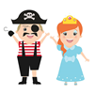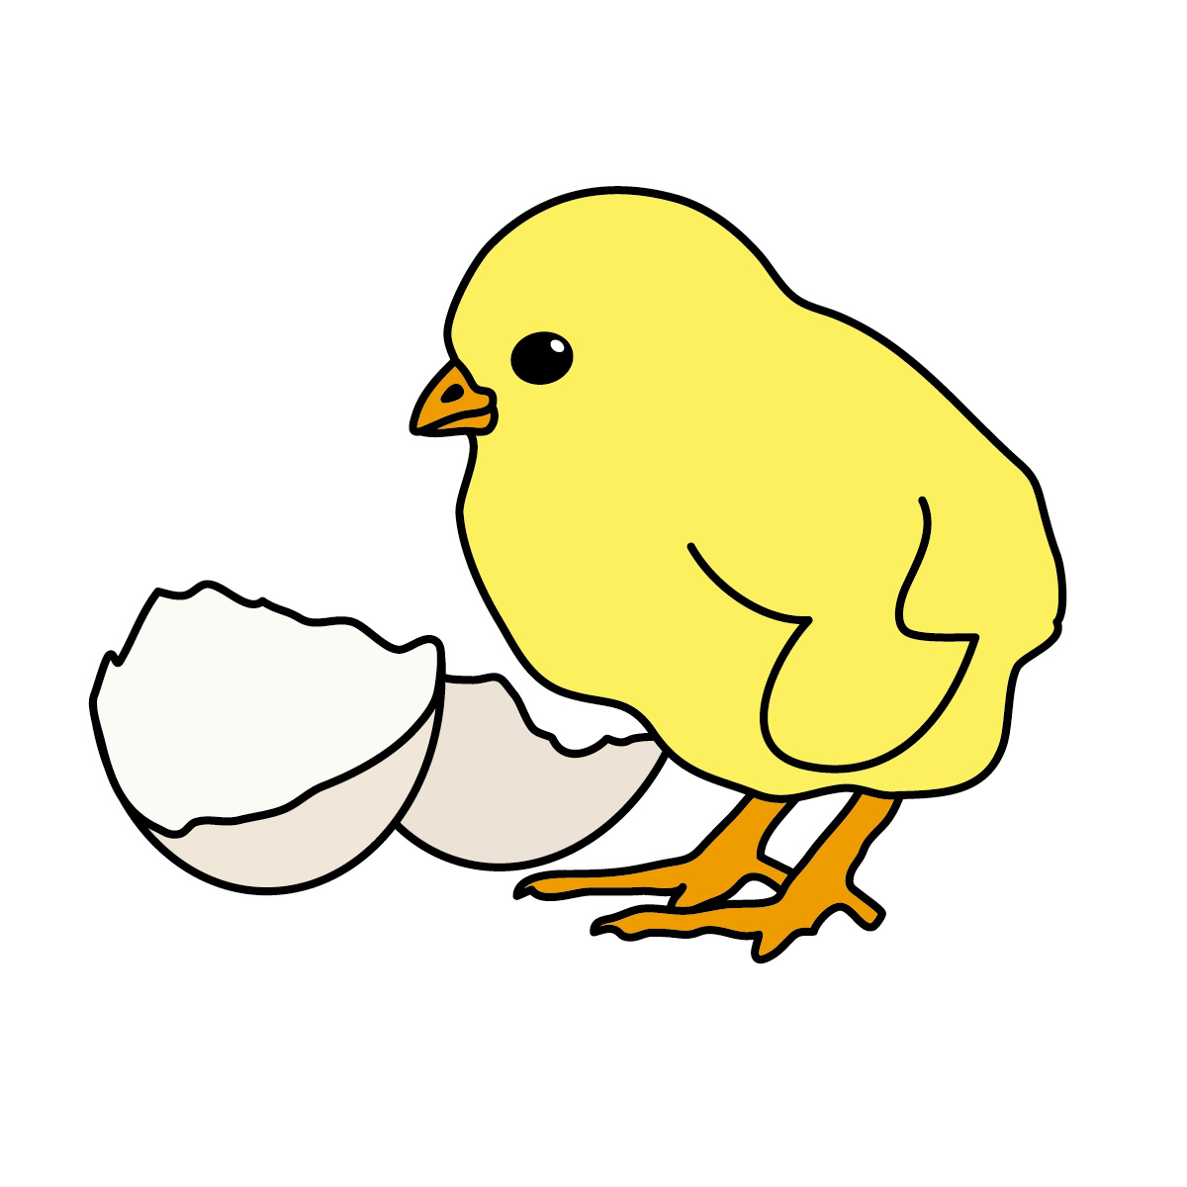  Easter | Growing, Lifecycles and In the Garden  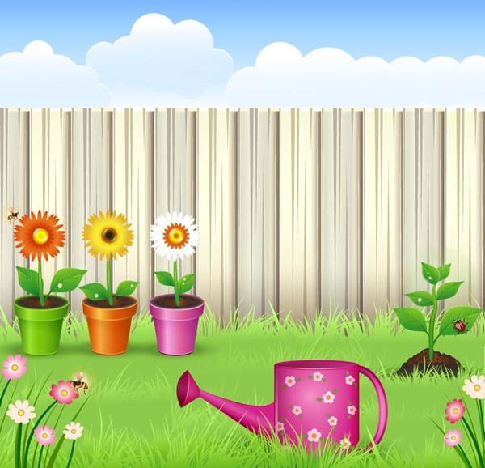  National Bee Day |  | Oh I Do Like to be Beside the Seaside!  International Mud Day
Key experiences | Getting to know our teachers and making new friends  Harvest | Pantomime  Nativity w/KS1 |  | Visits from people who help us in our local community |  | Reflective story visit-Discovery Centre  Easter service | Caterpillars  Hollowtrees Farm Trip |  | Summer Show  Sports Day  Transition to Year 1
ROLE PLAY AREA | House-multicultural | Santa’s grotto |  | Police station/hospital/vets |  | Space rocket/dragon cave | Garden Centre/Farm shop |  | Ice cream parlour
CLL  Possible book hooks  (+Drawing Club books)  Children improve their literacy skills through high quality teaching every day, high quality resources and enrichments to provoke further reading and mark making to take place in all aspects of the curriculum.  Communication and Language is developed throughout the year through high quality interactions, daily group discussions, circle times, stories, singing, speech and language interventions  Phonics  Writing  Communication and Language | The Colour Monster, Super Duper You, Only One You, All Are Welcome, This is What We Do, A Girl Like Me, I Love My Hair, You Choose, Elmer, Rainbow Fish, Goldilocks and the 3 Bears, Not So Fast Songololo, Gingerbread Man, Owl Babies | Handa’s Surprise, Pumpkin Soup, The Nativity, Christmas Around the World, Selection of Christmas theme stories |  | Traction Man, Michael Recycle and Litterbug Doug, Superworm, The Complete Book of First Experiences-hospital/Dr/school/dentist |  | The Night Pirates, Aliens Love Underpants, Zog, Abiyoyo, How to Catch a Dragon, Give Me My Yam, Dinosaur Roar, Bumpus Jumpus Dinosaurumpus, Anansie stories, traditional tales, How to Catch a Star, Whatever Next, The Darkest Dark, The Gruffalo | The Tiny Seed, One Child One Seed, Oliver’s Vegetables, Supertato, Jack and the Beanstalk, What the Ladybird Heard, Jim and the Beanstalk, Jasper’s Beanstalk, The Very Hungry Caterpillar, Farmer Duck |  | Commotion in the Ocean, Tiddler, Flotsam, Billy’s Bucket, What’s in the Pan, Man? Mister Seahorse, What the Ladybird Heard at the Seaside, Lucy and Tom at the Seaside, A House for Hermit Crab, Snail and the Whale, Sharing a Shell
 | Phonics initial assessment  RWInc Set 1  Writing letters and name  Alliteration | RWInc Set1  Rhyming strings  Linking sounds to letters  CVC word lists |  | Read RWINC Set 1  Reading and writing words, phrases and simple sentences |  | RWInc Set 2  Reading and writing words, phrases and simple sentences | RWInc Set 2  Writing sentences, applying phonetic and key word knowledge |  | RWInc Set 2  Writing sentences, applying phonetic and key word knowledge  RWInc Set 3 when ready
 | Name-can write own name correctly-ongoing  Initial sounds | Lists  Labels Simple sentences-shared writing |  | Labels  Lists  Questions  Non-fiction writing  Captions  Letter writing |  | Questions  Character descriptions  Write alternative endings to stories we have read-innovation | Non-fiction writing  Writing instructions  Setting descriptions  Recount of farm trip |  | Write own stories  Non-fiction-writing about sea creatures  Seaside Poems-senses
 | Maintain attention. Follow instructions. Use talk to organise ideas. | Developing listening skills and following instructions. |  | Understanding – following a story without props. Beginning to answer how and why questions. |  | Express views about characters and events. Introduce storyline of narrative into play | Develop own narratives. Answering ‘how’ and ‘why’ questions. |  | Listening attentively and expressing themselves effectively.
Maths  Children develop their mathematical skills through daily interactions, some direct teaching and some child initiated learning. High quality activities and resources are provided each day.  Mastering Number  White Rose-SSM | Subitising  Cardinality, ordinality and counting  Composition  Comparison  Just Like Me  Match and Sort  Compare mass, size and capacity  Exploring pattern  It’s Me 1 2 3  Circles and triangles  Positional language  Light and Dark  Shapes with 4 sides  Time |  |  | Subitising  Cardinality, ordinality and counting  Composition  Comparison  Alive in 5  Compare mass  Compare capacity  Growing 6,7,8  Length and height  Time  Building 9 and 10  3D shapes  Spatial awareness  Patterns |  |  | Subitising  Cardinality, ordinality and counting  Composition  Comparison  Consolidation of their understanding of concepts previously taught through working in a variety of contexts and with different numbers.  To 20 and beyond  Spatial reasoning  Match, rotate, manipulate  First, then, now  Spatial reasoning  Find my pattern  Spatial reasoning  Visualise and build  On the move  Patterns and relationships  Spatial reasoning  Mapping
PD  Children improve their gross and fine motor skills daily by engaging in different fine motor activities (threading, cutting, drawing weaving, playdough), mark making, construction, drawing, writing, Dough Disco and a weekly Gym Trail.  Gross Motor  Fine Motor | Introduction to PE-spatial awareness, developing gross motor skills.  Pre-letter patterns  Pencil grip |  | Ball skills-throwing and catching, kicking  Letter formation  Scissor skills | Dance  Scissor skills | Fundamentals  Using tools |  | Games  Forming letters correctly. | Gymnastics  Sports Day skills  Skipping  Handling tools effectively.
Gross Motor: Daily opportunities for physical activities in the outside area.
Fine Motor: Daily Funky Fingers sessions to develop pincer grip and strong hand and finger muscles.

EAD  A wide range of creative opportunities are available each day, some to directly teach a new skill and some to embed existing experiences and skills taught. Children are provided with a range of materials to enable them to decide the best to use for their own planned projects.  DT  Music:  (Charanga) | Continuous provision – inside and outside-children have access to materials for Art and Design. Pens pencils, chalks, junk, scissors, glue, magazines, paint, wax crayons, dough, different papers, construction kits etc  Drawing – As part of general routine and to illustrate work. Taught and own attempt in sketch books – self-portraits, daffodils, fruit and veg, shells Story characters-by following instructions  Painting – Topic pictures, colour mixing, different brushes, on the table, splatter painting-fireworks, powder paint-Holi  Printmaking – using stamps, vegetables, string, folding paper in half, table print.  Textiles/collage – Sewing for Christmas cards, Weaving -Kente patterns, circle weaving and different wall scenes to go with topics, Mask making-A is for Africa, Henri Matisse-The Snail  3D – Junk modelling, dough, clay pots for Mothering Sunday, construction kits, daffodils for Easter, Chinese dragon for Chinese New Year.  Artist- Andy Goldsworthy – looking at and working in the style of.  Exploring colour (mixing)  Talk about processes and ideas.  Combining different media-junk modelling  Represent own ideas through different media.  Using imaginations, creating storylines and narratives.
 | Models of our houses  Gingerbread biscuits | Bird feeders  Christmas decorations |  | Junk modelling-superhero vehicles  Chinese New Year-dragon, envelopes, Chinese food- noodles/stir fry |  | Models of castles/pirate ships/space rockets etc.  Easter chocolate  Easter garden | Junk modelling-bugs/flowers/beanstalks  Bug hotel |  | Under the sea scene-shoe box  Pop-up puppet  Junk modelling-boats
 | Me! | Nativity |  | My Stories |  | Everyone | Our World |  | Big Bear Funk
PSED  Children develop their personal, social and emotional skills throughout the year through high quality interactions and modelling, circle times, social stories, PHSE, diversity stories | Building relationships with our teachers and friends.  School and class rules.  Appreciate what makes us unique.  My Family.  Caring friendships. | Being Kind.  Managing feelings.  Recognising others have feelings.  Understanding the feelings of others.  Fire safety.  Friendships-Rama and Sita. |  | Setting goals for the new year.  Self-confidence, trying new activities and sharing ideas.  Caring for others and the environment.  Health and wellbeing (including oral health) |  | Continue to express interests and opinions (Follow me Friday)  Perseverance, resilience and independence. | Caring for the environment.  Showing sensitivity.  Awareness of behaviour and its consequences.  Understand the importance of healthy food choices. |  | Caring for the environment.  Knowing Myself-Likes and Dislikes  Feeling proud and setting goals.  Negotiation skills and co-operation within a group.
UtW  Children are invited to be curious and ask questions at every opportunity. Direct teaching and also stimulating environments are designed to encourage thought and interaction between adults and children, spanning a wide range of diverse subjects and cultures.  History  Geography  Science  Computing | Family routines. | Celebrations and customs: Diwali, Christmas around the world. |  | Chinese New Year traditions
 | Chronology-yesterday, today, tomorrow, days of the week, months of the year, class birthdays | How long have different celebrations and customs taken place for? How have they changed over time?  Christmas traditions |  |  |  | Traditional tales-how long have they been around?  Dinosaurs!  Space travel. |  |  | Introduction to how the seaside has changed over time.  Real pirates-Blackbeard!
 | Looking at our school environment-what are the natural and human features?  Seasonal walk | Where in the world do certain celebrations take place-find on a globe/map.  Find out how Christmas is celebrated around the world. |  | Comparing and contrasting Hintlesham with other locations such as mountains, seaside and forests. Walk around the local area-introduce following and drawing maps.  Find out about China  Seasonal walk |  | Traditional tales-where in the world does the story come from? Anansie stories-Africa | Map work-What the Ladybird Heard  Seasonal walk |  | Map work-compass/direction-link to seaside and pirates.  Treasure maps  Geographical features of the seaside-make a lighthouse/beach hut  Researching holiday destinations
 | Looking at-how we have changed since we were babies.  What makes us unique-eye colour, skin colour, hair colour, fingerprints  Signs of Autumn | Signs of Winter  Freezing  Colour experiments |  | Similarities and differences between ourselves and others.  5 senses.  Signs of Spring  Making slime  Friction/gravity-using the ramps |  | Observations of animals.  Herbivores/carnivores  Freezing and melting | Life cycles-butterfly, ladybird, sunflower, dandelion, frog  Observations of plants/insects  Signs of Summer  Conditions needed for plants to grow-planting sunflowers  Bug hunts-using magnifying glasses and sorting them by similarities/differences  Investigating what a seed needs to grow-planting, predicting and explaining  Looking after the environment |  | Floating and sinking-choosing best materials to make a boat based on properties.  Recycling-plastic pollution
 | Shape Hunt/Animal Safari | Talking Technology |  | Nursery Rhyme Coding |  | Technology and Me | My Online Life |  | Beats and Rhymes
RE  (Emmanuel Project) | Why is the word God so important to Christians?  Whispering Allah into Baby’s ear: Muslim birth custom | Why do Christians perform nativity plays at Christmas?  The Muslim story of Muhammad caring for the Ants |  | How can we help others when they need it?  The Sikh story of Guru Har Gobind saving the 52 Princes |  | Why do Christians put a cross in an Easter garden?  The Buddhist story of the Monkey King | What makes every single person unique and precious?  A Hindu festival for brothers and sister: Raksha Bandhan |  | How can we care for our wonderful world?  Tu B’Shevat-the Jewish holiday for planting trees

