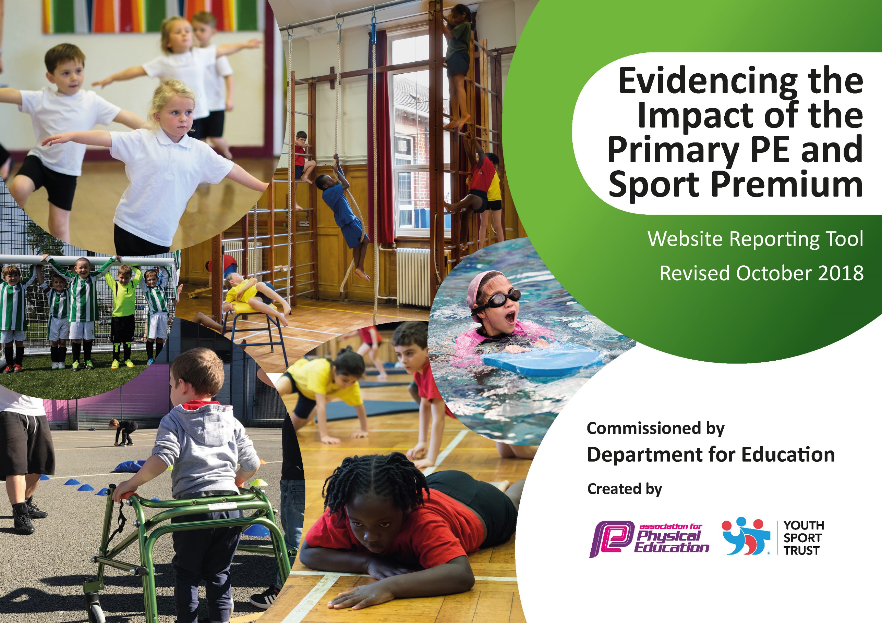
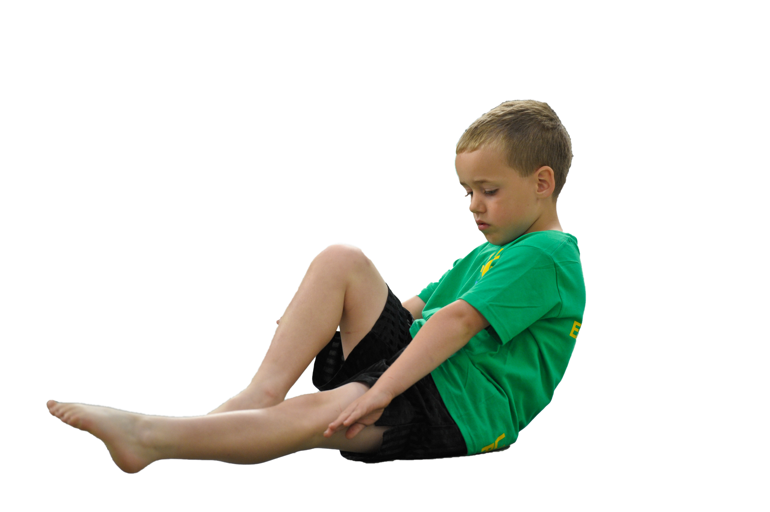
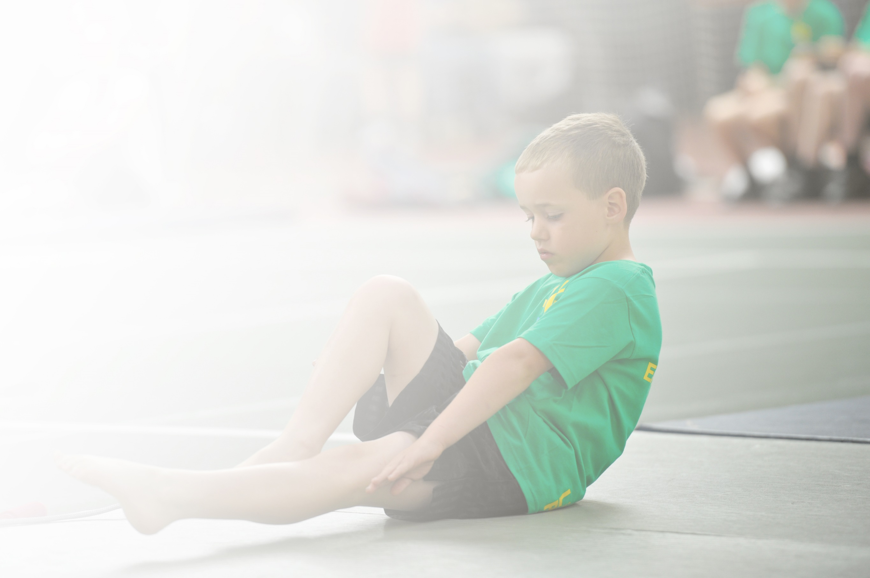
Schools must use the funding to make additional and sustainable improvements to the quality of Physical Education, Sport and Physical Activity (PESPA) they offer. This means that you should use the Primary PE and Sport Premium to:

- Develop or add to the PESPA activities that your school already offer
- Build capacity and capability within the school to ensure that improvements made now will benefit pupils joining the school in future years

Please visit gov.uk for the revised DfE guidance including the 5 key indicators across which schools should demonstrate an improvement. This document will help you to review your provision and to report
your spend. DfE encourages schools to use this template as an effective way of meeting the reporting requirements of the Primary PE and Sport Premium.

We recommend you start by reflecting on the impact of current provision and reviewing the previous
spend. Under the Ofsted Schools Inspection Framework, inspectors will assess how effectively leaders use the Primary PE and Sport Premium and measure its impact on outcomes for pupils, and how effectively governors hold them to account for this.

Schools are required to publish details of how they spend this funding as well as on the impact it has on pupils’ PE and sport participation and attainment by the end of the summer term or by 31 July 2019 at the
latest.
We recommend regularly updating the table and publishing it
on your website throughout the year, as evidence of your
ongoing review into how you are using the money to
secure maximum, sustainable impact. To see an
example of how to complete the table please
click HERE.

Support for review and reflection - considering the 5 key indicators from DfE, what development needs are a priority for your setting and your students now and why? Use the space below to reflect on previous spend, identify current need and priorities for the future.

Key achievements to date: | Areas for further improvement and baseline evidence of need:
The school enjoys a large participation in competitive events as part of the PE Partnership. The PE curriculum enables the children to practice, deelop and apply their new skills prior to competition.  A balanced curriculum enables the children to access a variety of sports / activities that allows greater opportunities to develop self-confidence and physical wellbeing.  External coaches have engaged children in all year groups and provided an insight to specific sports. | Investigate and secure a sports provider to deliver high quality coaching across a range of sports and activities including after school clubs.  Develop the sporting expertise of the staff through targeted CPD.  Consider and evaluate the extension of swimming to Year 4 and the opportunity to use alternative venue (Birch Farm Swimming Pool).

Meeting national curriculum requirements for swimming and water safety | Please complete all of the below:
What percentage of your current Year 6 cohort swim competently, confidently and proficiently over a distance of at least 25 metres?  N.B. Even though your children may swim in another year please report on their attainment on leaving  primary school. | 100 %
What percentage of your current Year 6 cohort use a range of strokes effectively [for example, front crawl, backstroke and breaststroke]? | 93 %
What percentage of your current Year 6 cohort perform safe self-rescue in different water-based situations? | 100 %
Schools can choose to use the Primary PE and Sport Premium to provide additional provision for swimming but this must be for activity over and above the national curriculum requirements. Have you used it in this way? | Yes  Year 5 children have taken part in swimming lessons.

Action Plan and Budget Tracking
Capture your intended annual spend against the 5 key indicators. Clarify the success criteria and evidence of impact that you intend to measure to evaluate for students today and for the future.

Academic Year: 2018/19 | Total fund allocated: £16920 | Date Updated:26/7/19
Key indicator 1: The engagement of all pupils in regular physical activity – Chief Medical Officer guidelines recommend that primary school children undertake at least 30 minutes of physical activity a day in school |  |  |  | Percentage of total allocation:
 |  |  |  | 27%
School focus with clarity on intended impact on pupils: | Actions to achieve: | Funding allocated: | Evidence and impact: | Sustainability and suggested next steps:
Children participate in a minimum of 2 PE (2 hours) lessons per week.  The Daily Mile has been launched in the school from Feb 2019 enabling children to take part in physical activity within the school grounds.  The school outside areas (including the MUGA) offer an open space where children can access equipment and a positive environment to develop key skills in friendship and teamwork.  The school field is to be brought up to the standard required for sports for all children to take part safely on it.  The hall floor to be brought up to the standard required with resurfacing and addition of marking to allow PE lessons to take part safely and in line with higher standards. | - Develop the concept of the Daily Mile and embed across the school as part of school life.  - Establish a Sports Council consisting of children who are passionate about raising the level of sport and engagement across the school.  - Investigate and secure a sports provider to deliver high quality coaching across a range of sports and activities including after school clubs.  - Obtain quotes to have the field levelled and reseeded to allow for participation in sport on the surface safely.  - Obtain quotes to have the hall floor resurfaces and the addition of court markings to allow for safe participation in higher quality sport. | £4623.31 | NC and PE long term plan specifies the sport / activity on a 2-year rolling basis.  The Daily Mile initiative will be a whole school event celebrated in assemblies to share success and details recorded on the schools biweekly newsletter to parents.  Attendance is recorded and submitted for verification as part of the School Games Award.  The field will be a space in which sport can safely take part on rather than needing to go offsite to the community ground. | - Investigate and discuss a long-term plan for extending swimming opportunities to children in KS1.  - Investigate and secure a sports provider to deliver high quality coaching across a range of sports and activities including after school clubs.  - Ensure an equal balance of sport and activities for KS1 and KS2.  - Put in place a regular maintenance schedule for protection of the field surface and hall surface.
Key indicator 2: The profile of PESSPA being raised across the school as a tool for whole school improvement |  |  |  | Percentage of total allocation:
 |  |  |  | 5%
School focus with clarity on intended impact on pupils: | Actions to achieve: | Funding allocated: | Evidence and impact: | Sustainability and suggested next steps:
The school will be hosting a wellbeing and sports week in May 2019. The aim is to provide a wide range of sporting activities to all. This will incorporate a Sports Day where parents are invited to celebrate and support the children’s participation. | - Dates have been arranged and set in diaries following staff meeting.  - There will be 2 sporting events: one based on developing skills and a second based on competitive races.  - Investigate a variety of activities that will engage and develop physical and emotional wellbeing. | £771.23 | All Sports Days activities took place as anticipated involving the whole school and wider communities of parents and Governors. The impact was for all children to take an active part in all of the events offered while being supported to achieve their best by the wider community. | Continue to provide sports Days events that allow for inclusion of all of the pupils and also for success in all ranges of abilities through the bronze, silver and gold achievements in each year group.

Key indicator 3: Increased confidence, knowledge and skills of all staff in teaching PE and sport |  |  |  | Percentage of total allocation:
 |  |  |  | 40%
School focus with clarity on intended  impact on pupils: | Actions to achieve: | Funding  allocated: | Evidence and impact: | Sustainability and suggested  next steps:
The teaching staff are small; however we have a number of skills that support the development of children’s skills and confidence in sport. | - Teachers / HLTA / TA to consider an area of development related to PE as part of their personal development.  - Staff to develop close links with the external sports provider leading their class and draw upon the coaching and key skills taught in the lesson. | £6183 | Lesson observations / dips carried out by the PE lead indicate that the teaching of PE is consistent and challenges the children taking part.  Parent feed back from the Parent Forum suggests areas for development that parents believe will enhance the development of the children. An example of which was the introduction of the Daily Mile. | - Provide staff with information relating to courses.  - Plan and implement cover for any adults taking part in courses that will support the delivery and quality of PE across the school.
Key indicator 4: Broader experience of a range of sports and activities offered to all pupils |  |  |  | Percentage of total allocation:
 |  |  |  | 12%
School focus with clarity on intended  impact on pupils: | Actions to achieve: | Funding  allocated: | Evidence and impact: | Sustainability and suggested  next steps:
Additional achievements:  Hintlesham & Chattisham have invited external coaches to deliver coaching or taster sessions for several sports and activities.  After school / lunch time clubs have been established to allow all children access to a range of activities to suit their interests. These include, Fitness, Multi Sports, Table Tennis, Basketball, Dodgeball and Badminton.These activities are directly linked with up and coming competitive events as part of the Primary PE partnership.  Bikeability for Year 6 on a rolling programme for all Year 6 children in the future. | - The following events have successfully taken place:  Swimming Lessons – KS2 – Autumn 1&2.  Skipping Workshop – Autumn 2  Badminton Coaching – KS1 & after school club – Spring 1  Tennis coaching – KS1 & after school club – Summer  - Further clubs to be run in the Spring / Summer 2019. Subject Lead is currently sourcing a provider that will be sustainable and reliable.  - This will facilitate enjoyment and safety within a currently expanding sport that can be enjoyed long-term through their lifetime. | £2019.20 | These events have enabled full participation from all the targeted year groups and ensured each child has experienced the sport and developed a range of skills.  All participants are recorded and monitored for trends and to identify any cohorts that are not being engaged.
Key indicator 5: Increased participation in competitive sport |  |  |  | Percentage of total allocation:
 |  |  |  | 17%
School focus with clarity on intended  impact on pupils: | Actions to achieve: | Funding  allocated: | Evidence and impact: | Sustainability and suggested  next steps:
Hintlesham & Chattisham is part of the local PE Primary Partnership and enrolled with School Games (Silver Award). This relationship offers the children a range of sporting activities that can be experienced at competition or in a coaching role. | - School is a member of the School Games Award Scheme (Silver) and a member of the Primary PE Partnership.  - Ensure ALL children have the opportunity to represent the school or take part in an event. | £2960 | Children from the school have taken part in a number of sporting activities (9 to date) ranging from Trampolining to Swimming Gala.  Numbers participating in these events are recorded and submitted for verification as part of the School Sports Award. | - In order to increase the attendance of sporting fixtures funding may be required to hire transport for competitions that take place in the afternoon.

